**Anystidae Fact Sheet** Dean Gladish

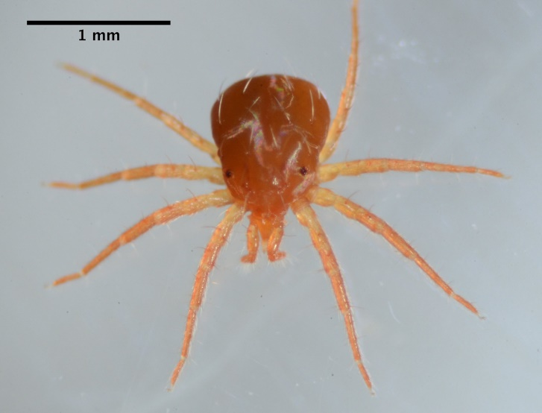**Scientific Name: Family Anystidae Common Name: Whirligig Mite**

**Range and Habitat:** The Anystid is present nearly everywhere on Earth. It is a predator of a wide range of small arthropods and thus can easily proliferate and control pests (Zhang 2003). The organism lives on exposed, dry surfaces including foliage, tree bark, and the ground (Walter 2005).

Kingdom: Animalia

Phylum: Arthropoda

Class: Arachnida

Subclass: Acari

Order: Trombidiformes

Suborder: Prostigmata

Family: Anystidae

(EOL 2017).

**Distinguishing Characteristics:** The Anystid is generally red or orange and quite small. The mite gets its common name from the fact that its long, well-developed legs extend outward from a single point on its body; this allows it to turn rapidly (BugGuide 2003). The rest of the body

contains a large number of bristles.

**The Order Trombidiformes and Taxonomy:**

The Trombidiformes order is important because it The jaws are separated, and each one of the mouth parts has two

contains some species such as eyelash mites and bristles. In conjunction with this are segmented pedipalps, each with

chiggers that are medically useful (iNaturalist 2017). three inwardly-facing spines on its fourth segment. The breathing

The taxonomic tree below, determined using past apparatus is positioned near the base of the mouth, and is supported

samples of organisms taken from the Arboretum, is by short structures. The red mite undergoes egg, larva, nymph, and

mostly accurate in its portrayal of relationships adult stages in its life cycle (Zhang 2003).

(Timetree 2017).

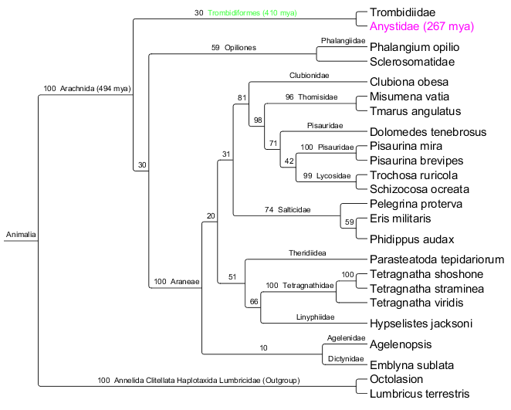**Additional Findings:** There are 17 genera and 98 species present within the family Anystidae (Wikimedia 2017). Certain species are among the fastest invertebrates in the world – the mite *Paratarsotomus macropalpis*, for instance, has been recorded to move at 322 body lengths per second (ScienceDaily 2014).

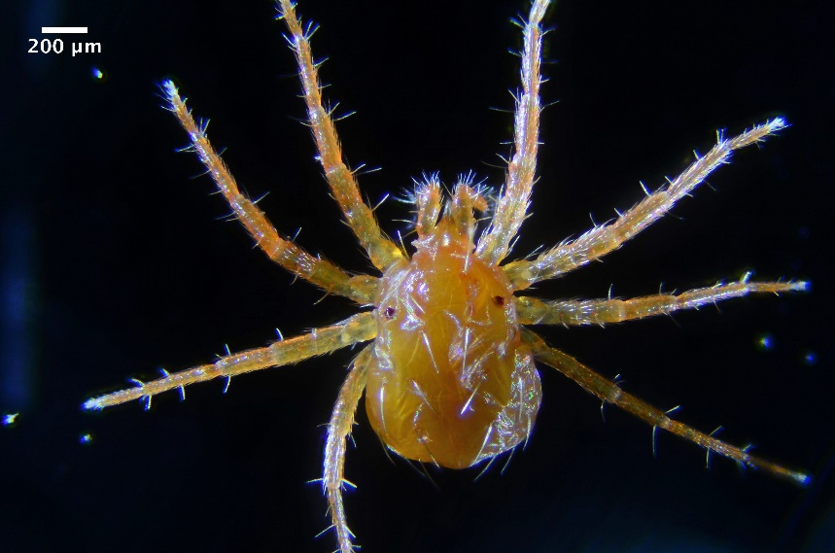

In the Arb, our Bio 125 class has collected many

different species; due to the small sample size and the

limitations of barcoding, the genera and species

obtained from Trombidiformes remain unidentified. (Images from D. Loarie)

Presently we have collected two distinct families –

these are Anystidae and Trombidiidae. Between samples from these families, 30.9% of base pairs varied within the COI gene. It is interesting to note that between samples collected from Anystidae and the Family Sclerosomatidae of Opiliones (common name Harvestmen), only 30.3% of base pairs varied within the COI gene (Clustal Omega 2017).

**Literature Cited**

Anystidae. 2017. Anystidae - Wikispecies. https://species.wikimedia.org/wiki/Anystidae.

Family Anystidae - Whirligig Mites. 2003. BugGuide. Iowa State University. https://bugguide.net/node/view/94327/data.

Hedges, B., and S. Kumar. 2005. TimeTree (Taxa Group). TimeTree: The Timescale of Life. http://timetree.org/.

Higgins, D., F. Sievers, D. Dineen, and A. Wilm. 2017. Clustal Omega. Clustal Omega: Multiple Sequence Alignment. EMBL-EBI. http://www.ebi.ac.uk/Tools/msa/clustalo/

Loarie, D. 2013. Mite - Family Anystidae. Flickr. Photograph. https://www.flickr.com/photos/loarie/8700966885/. https://www.flickr.com/photos/loarie/8697968286/in/photostream/ https://creativecommons.org/licenses/by-nc-sa/2.0/legalcode.

Newton, B. 2004. Spiders of Kentucky - University of Kentucky Department of Entomology. (R. Bessin & B. Newton, eds.) University of Kentucky. http://www.uky.edu/Ag/CritterFiles/casefile/spiders/anatomy/spideranatomy.htm.

Rubin, S. 2014. Mite sets new record as world's fastest land animal. ScienceDaily. Federation of American Societies for Experimental Biology. https://www.sciencedaily.com/releases/2014/04/140427191124.htm

Trombidiform Mites (Order Trombidiformes). A Community for Naturalists. iNaturalist.org. https://www.inaturalist.org/taxa/83740-Trombidiformes.

Walter, D. E. 2005. Anystides. ITP. http://itp.lucidcentral.org/id/mites/invasive_mite/Invasive_Mite_Identification/key/Major_Mite_taxa/Media/Html/Anystides.htm.

Walter, D. E. 2005. Glossary of Acarine Terms. ITP. http://itp.lucidcentral.org/id/mites/invasive_mite/Invasive_Mite_Identification/key/0_Glossary/Mite_Glossary.htm.

Whirligig Mites - Anystidae – Overview. Encyclopedia of Life. http://eol.org/pages/3206787/overview.

Zhang, Z.Q. 2003. Mites of Greenhouses: Identification, Biology and Control. CABI. https://books.google.com/books?id=zVaSCyiK540C&pg=PA214#v=onepage&q&f=false.